TASK-1
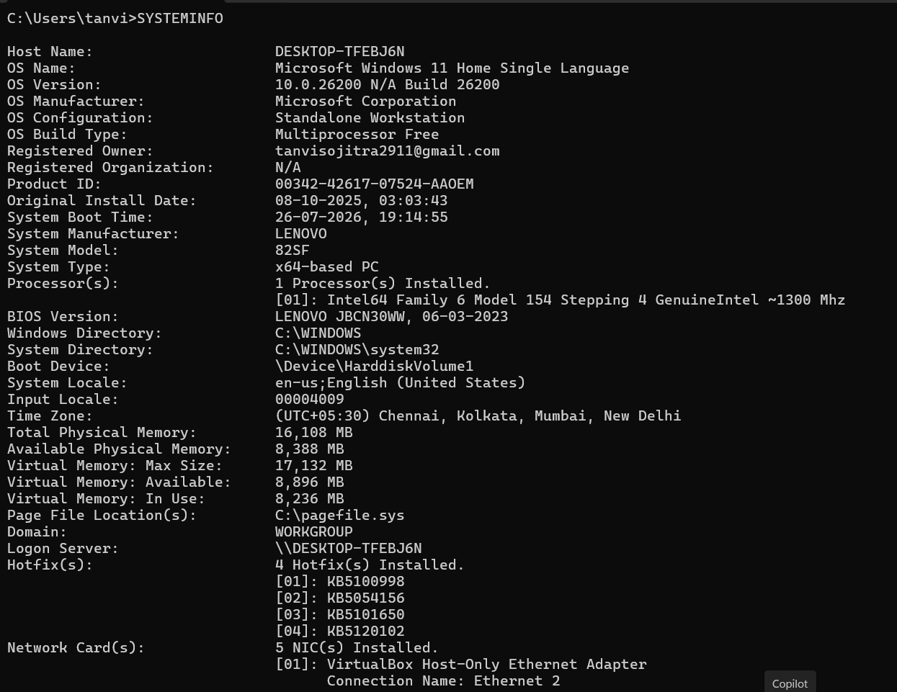

TASK-2
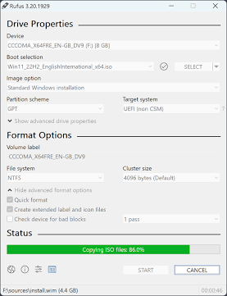
Here is the step-by-step process to download a Linux ISO and create a bootable USB drive using Rufus or BalenaEtcher, along with a VirtualBox alternative if you don't have a spare flash drive.
Method 1: Create a Bootable USB Drive (Using Rufus / BalenaEtcher)
Warning: Flashing an ISO will erase all existing data on the USB drive. Ensure you back up any critical files on the drive before proceeding.
1.Download the ISO & Utility Tool:Minimum 8 GB drive required.
- Download Linux ISO: Go to the official download page for Ubuntu Desktop or Fedora Workstation and save the .iso file.
- Download Utility:
  - Rufus (Windows): Download from the official website (rufus.ie).
  - balenaEtcher (Windows, macOS, Linux): Download from etcher.balena.io.
2.Connect USB & Open the Utility:Select hardware target.
- Insert your USB flash drive into your computer.
- Launch Rufus (or balenaEtcher).
- Confirm that your USB drive is selected under the Device section (Rufus) or Select target (balenaEtcher).
3.Select the ISO File:Load ISO image.
- Rufus: Click the SELECT button next to Boot selection, navigate to your Downloads folder, and choose your downloaded .iso file. Leave Partition scheme set to GPT and Target system set to UEFI (non CSM) for standard modern PCs.
- balenaEtcher: Click Flash from file and select the .iso file.
4.Start Flashing the Drive:Write files to drive.
- Click START in Rufus (or Flash! in balenaEtcher).
- If Rufus prompts to download additional Syslinux/ISOLybrid files, click Yes, and select Write in ISO Image mode (Recommended).
- Accept the warning prompt confirming that all data on the USB drive will be formatted.
- Wait for the status bar to show READY (100% complete).
Alternative Method: Test Virtually via VirtualBox
If you don't have a spare USB drive, you can mount the ISO directly in a virtual environment:
- Download and install Oracle VM VirtualBox.
- Open VirtualBox and click New.
- Name your Virtual Machine (e.g., Ubuntu Linux), select Linux as the type, and browse to set the ISO Image field directly to your downloaded .iso file.
- Allocate RAM (4 GB minimum recommended) and CPU cores, then click Finish.
- Select your new VM and click Start to boot directly into the live Linux environment.
TASK-3
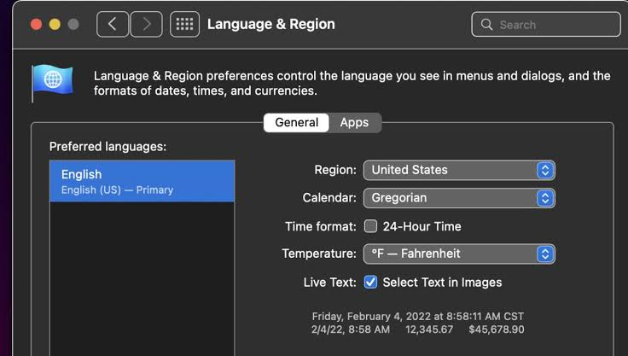

TASK-4
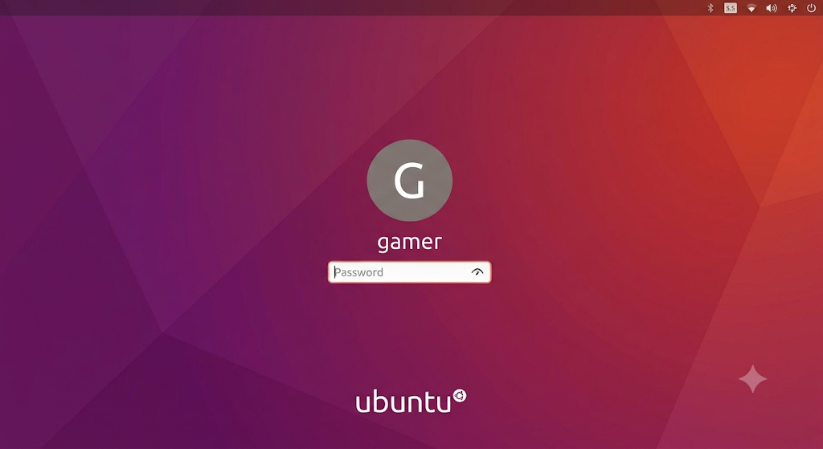
TASK-5
Here is the absolute fastest, jargon-free way to install Windows 10
1. Make the USB Drive
- Plug an 8GB (or larger) USB drive into a working computer.
- Go to Microsoft’s Windows 10 download page and get the Media Creation Tool.
- Run the tool and choose Create installation media. Let it format your USB.
2. Boot Your Laptop
- Plug the USB into the laptop you want to upgrade/fix.
- Turn the laptop on and immediately tap F2, F12, or Esc repeatedly until a menu appears.
- Select your USB drive to boot from it.
3. Install & Partition
- Click Install Now and select I don't have a product key (it activates later).
- Choose Custom: Install Windows only.
- The trick: Click on every drive partition listed and hit Delete until you only see "Unallocated Space."
- Click the Unallocated Space, hit Next, and let Windows install. The laptop will restart a few times.
4. Setup & Privacy
- When the setup screen appears, choose your region and keyboard.
- Click I don't have internet if you want to avoid making a Microsoft account and just use a local offline profile.
- Privacy: When you see the screen with toggles for Location, Diagnostic Data, and Advertising ID, turn them all OFF.
5. Update
- Once you see the desktop, connect to Wi-Fi.
- Open Settings > Update & Security > Windows Update and click Check for updates. This automatically downloads your missing drivers and secures the system.

